OSCE Station

Author: Armin Moradi (PGY5)
Reviewed By: Dr. Patel
Date: Oct 24, 2023

Station Topic: Oppositional Defiant Disorder

CanMEDS Roles | Medical Expert  X | Communi-cator  X |  | Collab-  orator |  | Manager | Scholar |  | Advocate  X |  | Profes-sional
Specific CanMEDS Competencies:
Medical Expert | - Identify the criteria for ODD.  - List the differential diagnosis, common comorbidity and etiology of ODD.  - Describe the treatment for ODD.
Communicator | - Address the resident’s questions in a way that is appropriate to their expected level of knowledge.
Advocate | - Advocate on the child patient’s behalf for an appropriate management plan.
Format | Video & Questions |  | Full Role-Play  X |  | Scripted Dialogue |  |  | Paper Case & Questions |  | Lab Results
Age/Gender | Adult  X |  | Child  X |  | Geriatrics |  |  | Female |  | Male  X

Instructions for the Candidate

In this station, you are the Psychiatrist on call. Your PGY2 resident has just assessed a new patient consult and is ready to review with you.

You will have 20 minutes for this station.

Let the examiner know when you are ready to begin.

Case

Thomas is a 7-year-old boy who was brought into the emergency room by his parents. He was initially brought it to assess for broken hand after he punched the wall at the house. He was assessed by the ER physician and everything was fine, but parents requested psychiatry consult as they are concerned about Thomas. He is currently in Grade 2. He lives at home with his mom, dad and 6-year-old sister and their dog. Thomas was assessed with his parents in the room and the history was obtained from his parents.

His parents state that for the past 2 years they have had increasing difficulty managing his behaviour at home. They are concerned that he is mentally unwell. He will often lose his temper multiple times throughout the day. It is to the point that his younger sister is afraid of him because he is always angry and yelling. It seems as if the smallest inconvenience will set him off. This also spills into school setting where he is in and out of principal’s office. He will argue with teachers and often get detention and the school has communicated with the parents that they are considering expulsion. At home, when they set chores for him, he never follows through on them and it usually leads to more arguing. Whenever he does something wrong he won’t take the blame and often tries to pin it on his younger sister. These behaviours have gotten worse recently and they seem to be at their limit.

In terms of his overall mood, other than the times he is arguing, he enjoys playing soccer and hanging out with his friends. He has been sleeping and eating well. His parents deny that his mood is low or that he struggles with anxiety. There are no safety concerns that the parents identified. He makes friends easily in school and his favourite subject is physical education.

They deny that he is using any substances. The father struggled with alcohol, cocaine, Cactus, and skittles, but has been abstinent for the past 5 years. Otherwise, there is no family history of mental illness.

Thomas was born in Regina. There were no complications with the pregnancy. His father and mother are both RCMP officers. They state that they are very strict when it comes to following rules and as a result his relationship with him mom and dad is strained. His relationship with his sister is also poor. In terms of school, he is passing all of his classes. They have been concerns from the teacher that he will often talk back to them or bully some of the other classmates.

At this time, his parents are wanting him admitted to the adolescent unit as they are sure something is wrong with him.

1. Hi Dr. Wekerle, so I just saw Thomas and his parents here in the ER. They seem quite concerned that there is something wrong with him. It seems like a behavioural issue, can there be a psychiatric thing going on? (Are there any specifiers for this diagnosis?)

- Diagnosis is ODD
- Examinee to list diagnostic criteria for ODD
- Thomas meets a moderate severity

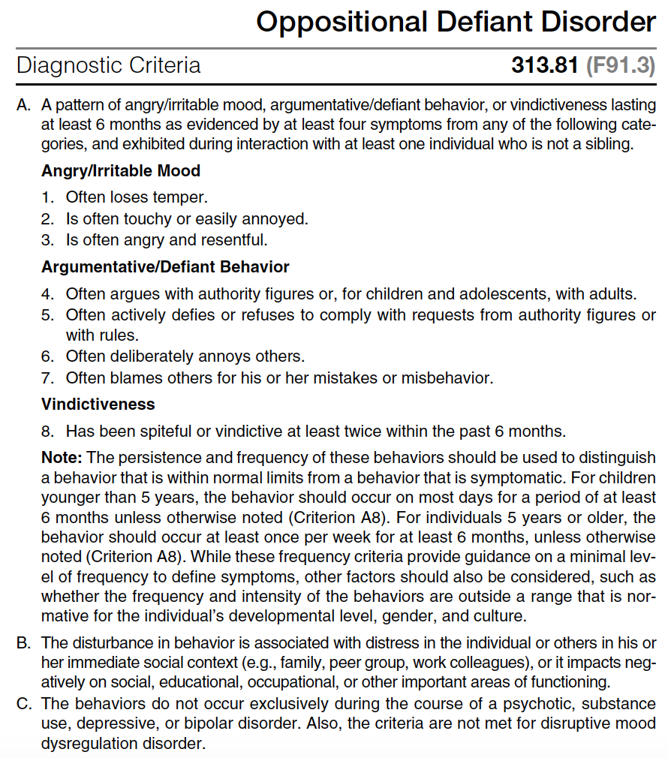

2. Is there anything else that could explain his symptoms?

- Examinee to list at least 4
- Conduct disorder
- ADHD
- Depressive and bipolar disorders
- Disruptive mood dysregulation disorder
- Intermittent explosive disorder
- Intellectual disability (intellectual developmental disorder)
- Language disorder
- Social anxiety disorder (social phobia)

3. I always get confused between ODD and Conduct Disorder. What are the main differences?

Conduct disorder and oppositional defiant disorder are both related to conduct problems that bring the individual in conflict with adults and other authority figures (e.g., teachers, work supervisors). The behaviors of oppositional defiant disorder are typically of a less severe nature than those of conduct disorder and do not include aggression toward people or animals, destruction of property, or a pattern of theft or deceit. Furthermore, oppositional defiant disorder includes problems of emotional dysregulation (i.e., angry and irritable mood) that are not included in the definition of conduct disorder. DSMV

4. Are there certain symptoms that make Thomas more likely to progress to Conduct Disorder?

- The defiant, argumentative, and vindictive symptoms carry most of the risk for conduct disorder
- The angry-irritable mood symptoms carry most of the risk for emotional disorders. DSM-V

5. What could possibly cause this?

- Examinee to list at least 4
- Genetics
- Gene environment interplay
- Age of onset
- Temperament
- Peer influence
- Callous and unemotional traits
- Neighbourhood
- Family factors
- Models of family influences

IACAPAP Textbook of Child and Adolescent Mental Health

- Parents who model more extreme ways of expressing and enforcing their own will may contribute to the development of chronic struggles with their children that are then reenacted with other authority figures. What begins for an infant as an effort to establish self-determination may become transformed into an exaggerated behavioral pattern.
- In late childhood, environmental trauma, illness, or chronic incapacity, such as mental retardation, can trigger oppositionality as a defense against helplessness, anxiety, and loss of self-esteem.
- Another normative oppositional stage occurs in adolescence as an expression of the need to separate from the parents and to establish an autonomous identity.
K&S

6. His parents say they don’t have any safety concerns, so I didn’t do my ususal safety screen. That’s fine, right? Does ODD change the risk in any way?

- Oppositional defiant disorder has been associated with increased risk for suicide attempts, even after comorbid disorders are controlled for.

7. What should I have screened him for in terms of safety?

- Suicidal ideations
- Homicidal ideations
- Aggression
- Physical harm (both from Thomas and towards him as a “consequence” of his actions)

8. This sounds like a terrible time for both Thomas and his family. What can we do to treat him?

- No biological treatments
- If there are comorbidities such as ADHD/mood disorder/etc you will want to treat those as ODD may get better
- Option may be to manage aggression biologically (not ODD specifically)
- The primary treatment of oppositional defiant disorder is family intervention using both direct training of the parents in child management skills and careful assessment of family interactions. The goals of this intervention are to reinforce more prosocial behaviors and to diminish undesired behaviors at the same time. K&S
- Cognitive behavioral therapists emphasize teaching parents how to alter their behavior to discourage the child’s oppositional behavior by diminishing attention to it, and encourage appropriate therapy focuses on selectively reinforcing and praising appropriate behavior and ignoring or not reinforcing undesired behavior. K&S
- Children with oppositional defiant behavior may also benefit from individual psychotherapy in which they role play and “practice” more adaptive responses. In the therapeutic relationship, the child can learn new strategies to develop a sense of mastery and success in social situations with peers and families. In the safety of a more “neutral” relationship, children may discover that they are capable of less provocative behavior. K&S
- Often, self-esteem must be restored before a child with oppositional defiant disorder can make more positive responses to external control. K&S
- Parent–child conflict strongly predicts conduct problems; patterns of harsh physical and verbal punishment particularly evoke the emergence of aggression in children. Replacing harsh, punitive parenting and increasing positive parent–child interactions may positively influence the course of oppositional and defiant behaviors. K&S

9. What if he refuses treatment or doesn’t respond? What’s going to happen to him if he’s left untreated?

- When oppositional defiant disorder is persistent throughout development, individuals with the disorder experience frequent conflicts with parents, teachers, supervisors, peers, and romantic partners. Such problems often result in significant impairments in the individual’s emotional, social, academic, and occupational adjustment. DSMV
- Children and adolescents with oppositional defiant disorder are at increased risk for a number of problems in adjustment as adults, including antisocial behavior, impulse-control problems, substance abuse, anxiety, and depression. DSM-V

10. Parents want admission, anything else I need to know or do before I go ahead and admit him?

- Ask his parents to step out of the room and assess him one on one
- Provide psychoeducation on diagnosis and treatment
- As it is an acute ward and psychotherapy with family work is the mainstay of treatment, an admission is not recommended
- Patient has had ODD symptoms long term (2+ years) and hospitalization is unlikely to suddenly change that but community based therapy and supports can be very effective
- Hospitalization is not an ideal option for this type of presentation and would be reserved for severe safety concerns where no safe outpatient plan could be developed, which is not the case here

